SOUTH CAROLINA STATE HEAD START ASSOCIATION, INC.
FATHERHOOD / MALE INVOLVEMENT COALITION
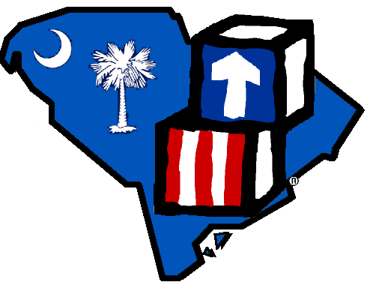
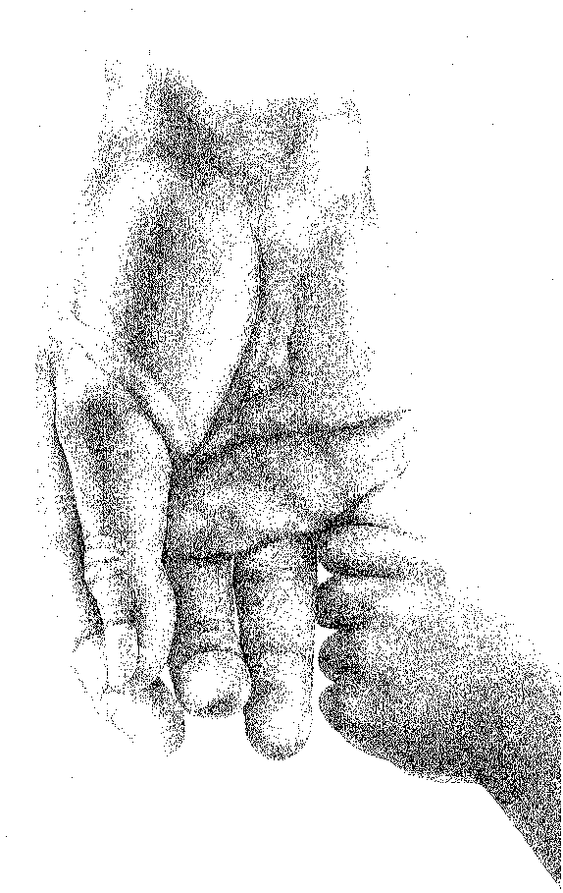 “Investing In Our Future… …… One Child At A Time”
_________________________________________________________________________________________
Orlandor Lewis, State President Telephone: (843)255-7222
1905 Duke Street, Ste. 250 Fax: (843)255-7225
Beaufort, South Carolina 29901 olewis@thebjeoc.org

Greetings on behalf of the SC State Head Start Association (SCSHSA). I am writing to you on behalf of the South Carolina State Head Start Association Fatherhood/Male Involvement Coalition to let you know of an opportunity that may interest you or your company. The (SCSHSA) Fatherhood/Male Involvement Coalition planning committee is extending an invitation to attend our 15th Annual Fatherhood/Male Involvement Coalition Conference that will be held May 5, 2025 – May 8, 2025 at the Sheraton Convention Center, Myrtle Beach, SC. This 4-day conference is slated to be one of the most exciting, informative and engaging events for Head Start/Early Head Start fathers, guardians and staff and partners.

The South Carolina State Head Start Association has operated 56 years, focusing on issues and advocacy to ensure high quality comprehensive service delivery for every eligible child and family in South Carolina. Over the past fifteen years, the SCSHSA has provided support and resources to increase the involvement of fathers/males in early childhood education as well as to increase family relationships.

If possible, we are seeking your support through a sponsorship or exhibition of your goods/services. Conference information and sponsorship levels are included. Please do not hesitate to contact me via email at scshsa1@outlook.com or telephone at (864)252-6425 or Monica McFarland, Conference Coordinator at (843)287-3982 should you have further questions. I hope that you will consider this appeal.

Warmest Regards,

Jerome Thompson- Fatherhood Coordinator
SCSHSA Fatherhood/Male Involvement Coalition

